CASE STUDY: AGILE ADAPTATION TO OPTIMIZE USER EXPERIENCE

1. Context & Initial Challenge
- Project: Family Guardian App
- Objective: To build a family safety app with features like location tracking, SOS alerts, and device monitoring.
Initially, the Family Guardian app was designed with a strict login process that required users to create an account via email or social media from the very beginning. The goal was to ensure security and personalization. However, during internal testing, we discovered a major problem: many potential users abandoned the registration process and left the app. The immediate login barrier became a serious drop-off point, hindering new user acquisition.
The challenge was to quickly address this issue without disrupting the development timeline, while still allowing users to experience the app's core features.

2. Analysis & Flexible Collaboration
Instead of sticking to the original plan, we collaborated closely with our client, Herond Labs, to analyze user behavior and formulate a new strategy.
- Behavioral Analysis: We identified that users wanted to try the app immediately before committing to creating an account. The complicated and time-consuming email registration process significantly reduced the conversion rate.
- Proposed Solution: DanaExperts proposed and developed an innovative new feature: "Anonymous User Usage." This feature allows users to explore the app and use some basic functionalities without providing any personal information.

3. Technical Solution & Rapid Implementation
To bring this solution to life, the DanaExperts team implemented a fast and flexible development cycle.
- Technology: We used Firebase Anonymous Login and Device ID to identify anonymous users.
- Data Handling Logic:
  - Anonymous user data is stored temporarily.
  - When the user decides to create an official account, all previously created data (e.g., safe zones, connected devices) is automatically migrated and merged into the new account.
- Redesigned User Flow:
  - We removed the mandatory login screen at the initial step.
  - We added banners and call-to-action (CTA) buttons on feature screens to encourage users to log in once they understood and appreciated the app's value.

4. Results & Business Impact
This close collaboration and rapid adaptability yielded highly positive results:
- Increased Conversion Rate: By removing the initial login barrier, we made it easier for users to access and experience the app, significantly increasing the installation and user retention rates.
- Valuable Real-World User Data: Allowing users to try the app first helped us collect valuable data on actual user behavior, which informed intelligent adjustments for subsequent features.
- Strengthened Partnership: DanaExperts provided this feature development free of charge as a commitment to the project's success, demonstrating that we are not just a development partner but also a strategic technical consultant.

5. Visuals & Suggested Content
- Before user flow
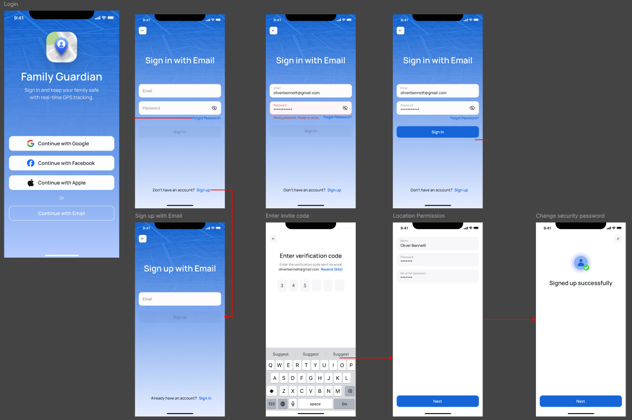

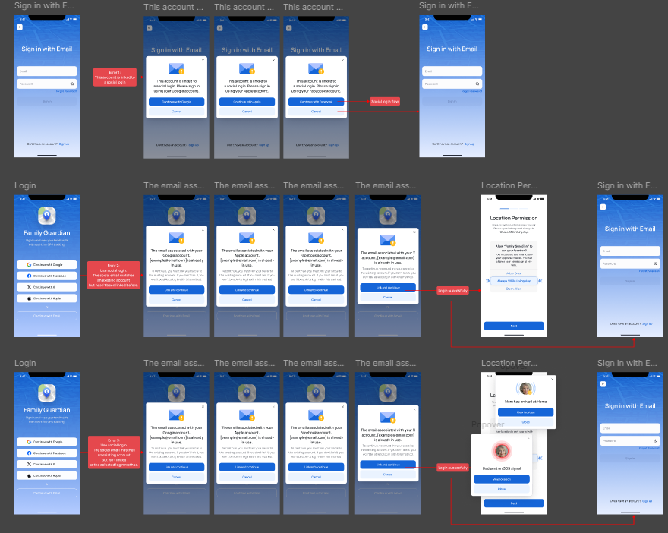
- After user flow
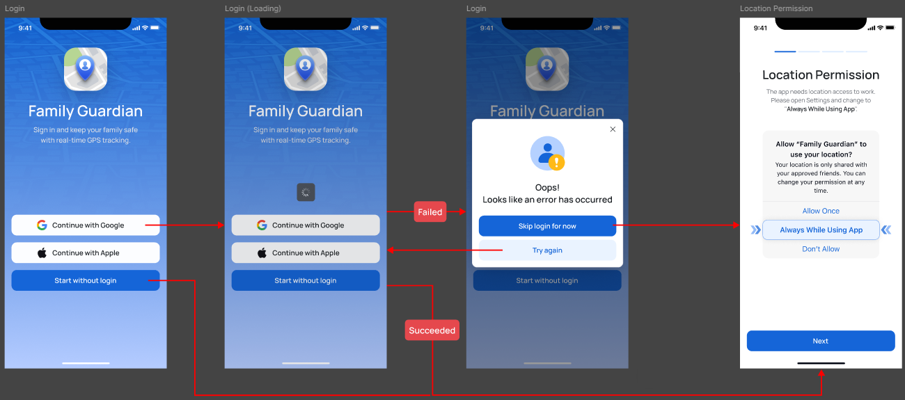

6. Conclusion
The Family Guardian project is a clear testament to the fact that modern software development goes beyond merely coding to a specification. By listening to the market, analyzing user behavior, and collaborating flexibly, DanaExperts and Herond Labs successfully created a product that not only works well technically but also truly meets the needs and behaviors of its users, delivering optimal business value.

